Module 11

11.2 Assignment
Course: CSD325 – 340A
Prepared By: Mirach Erkol
Date of Report: 12/14/25

Mikey5007/csd-325: csd-325

11.2 Assignment Screenshot #1: “Hello World!”
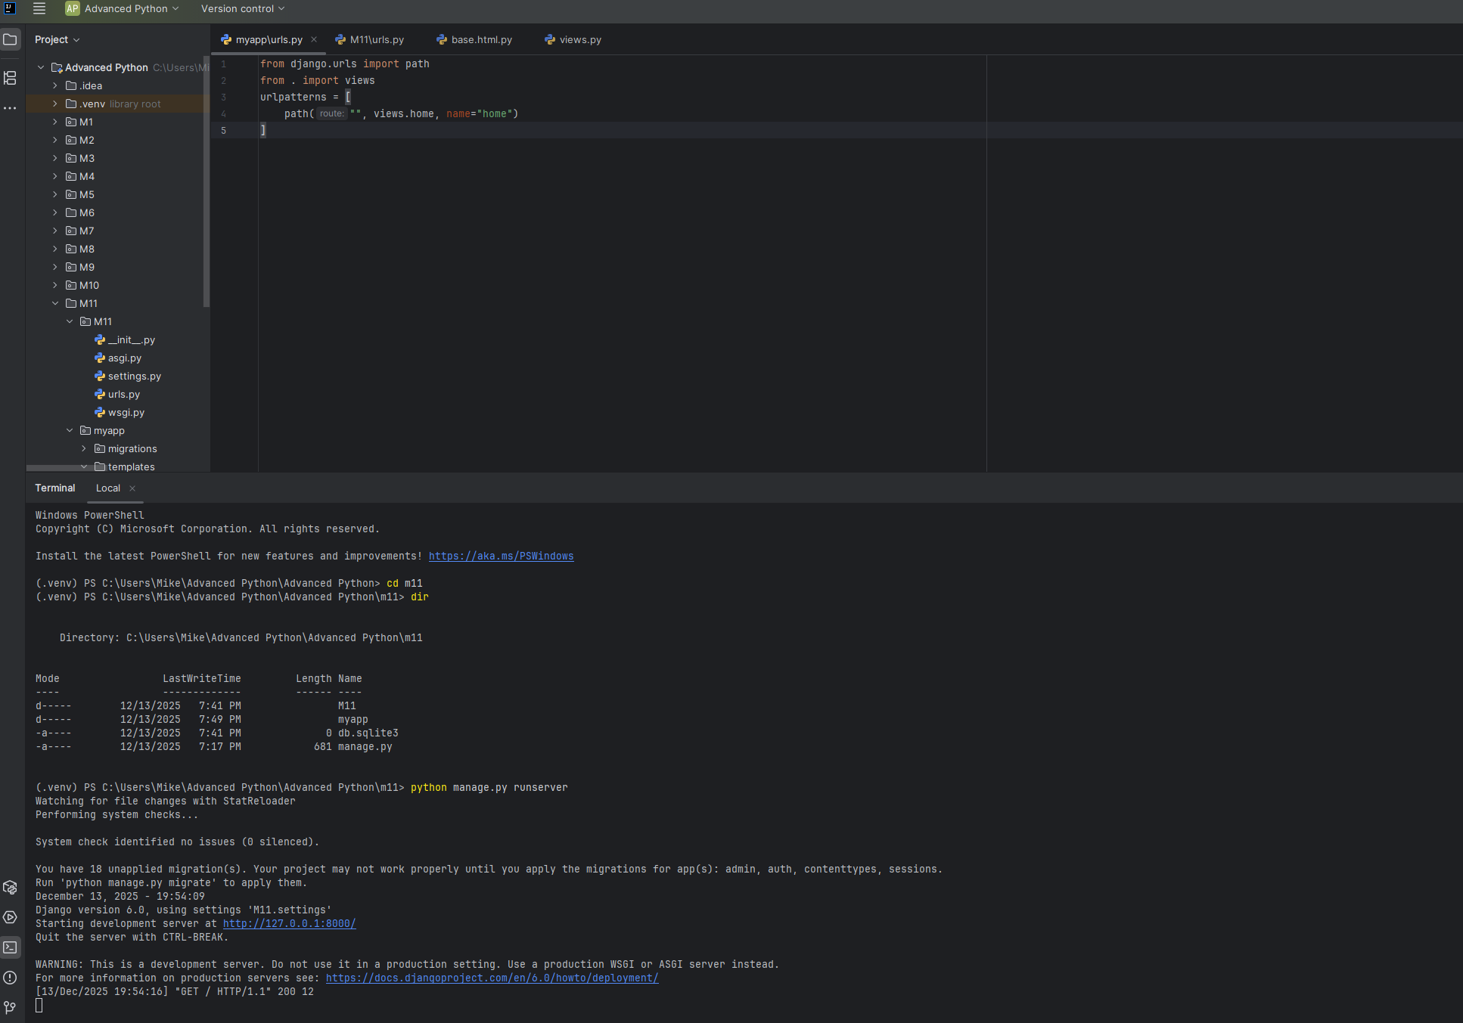
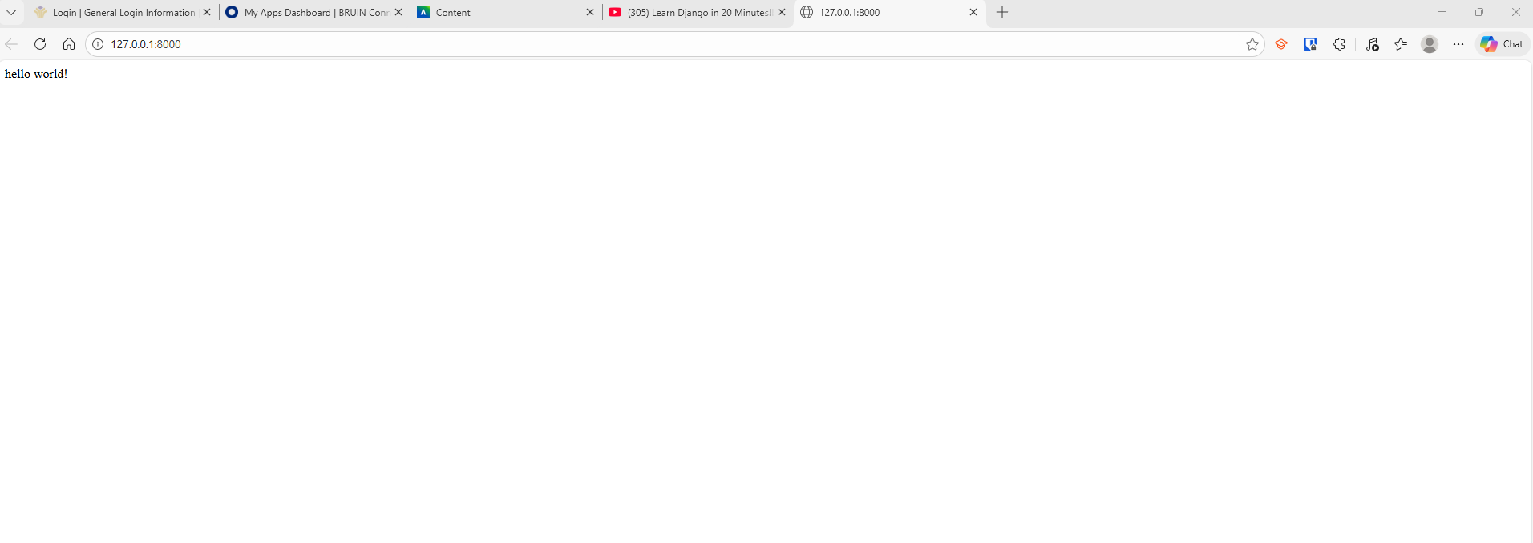

11.2 Assignment Screenshot #2: “Erkol says Hello!”
